**Name………………………………………………… Admission No…………….…………………**

**Student’s signature……………………….……. Date…………….………..……………………**

**FANAKA GIRLS HIGH SCHOOL**

**DECEMBER HOLYDAY ASSIGNMENT**

**TOTAL:**

**ENGLISH**

**FORM 2**

**2 Hours.**

**INSTRUCTIONS TO STUDENTS**

1. **Write your name and admission number in the spaces provided above.**
2. **Answer all the questions in this question paper.**

1. One of the school rules states:”ONLY English and Kiswahili are the official languages to use at school”. The school’s Head of Language Department has caught you speaking in your mother tongue. Write him the letter, apologizing for your action. (20 marks)

2**. CLOZE TEST**

**Read the passage below and fill in each blank space with the most appropriate word. (10 marks)**

”Beauty is only skin deep,” people often say, meaning ___________ beauty is unimportant and that what matters is __________lies hidden under the surface.___________ there is truth in this.

It is surface ____________enriches our lives to a great extent. What matters to most __________ us about a rose is not what it is made of; but what it looks ___________. The surface appeal of a thing does ____________ lie in its appearance but also in its feel, and often its smell, too. If for instance, we have to choose_____________ two crimson roses of equal beauty, we should surely choose the fragrant one. Nearly all of us __________ rather walk barefooted on a lawn than on a gravel path; we_______ to wear dry rather than wet clothes; we would choose soft clothes in preference to clothes made of sacks.

**ORAL SKILLS. (20 MARKS)**

**a)You are the class prefect of the form 2 class. Your class teacher finds students from your class shouting and screaming. You have been summoned by the teacher on duty to his office to give explanations. (10 marks)**

**TEACHER:** You are the class prefect of form 2A**,** aren’t you?

**YOU:__________________________________________________________________________________________________________ (1mk)**

**TEACHER:** Why was your class shouting and screaming?

YOU: _____________________________________________________________________________________________________ (2marks)

TEACHER: How exactly can you say that you are not sure and yet you were in class and you are the perfect?

YOU: ___________________________________________________________________________________________________________________________ (2 marks)

TEACHER: What! Are you sure of whatever you are saying? What actions did you take?

YOU: __________________________________________________________________________________________________________________________ (1mark)

**TEACHER:** That is exactly the opposite of what you should have done.

**STUDENT**: I am sorry sir, but it seemed like there was a great danger in the middle of the class. I had to run for my life.

TEACHER: when the noise subsided, what did you find out?

**YOU:_____________________________________________________________________________________________________________________ (1 mark)**

**TEACHER:** A chameleon**?**

**YOU: ________________________________________________________________________________________________________ (1mark)**

**TEACHER:** Whose toy chameleon was it?

**YOU: ________________________________________________________________________________________________________________________ (1 mark)**

**TEACHER:** You can go now, but I will need to know whose toy chameleon it was.

**YOU:_______________________________________________________________________________________ (1 mark)**

**b. identify the silent letters in each of the following words. (5marks)**

i) Snatch-

ii) Solemn -

iii) Damn-

iv) Thumb-

v) ) Duvet-

c) **Give the homophones of the following words. (5marks)**

**i)** Key –

ii) Heart-

iii) Stare-

iv) Our-

v) Damn-

**COMPREHENSION. (20 marks)**

**Read the following passage and answer the questions that follow**

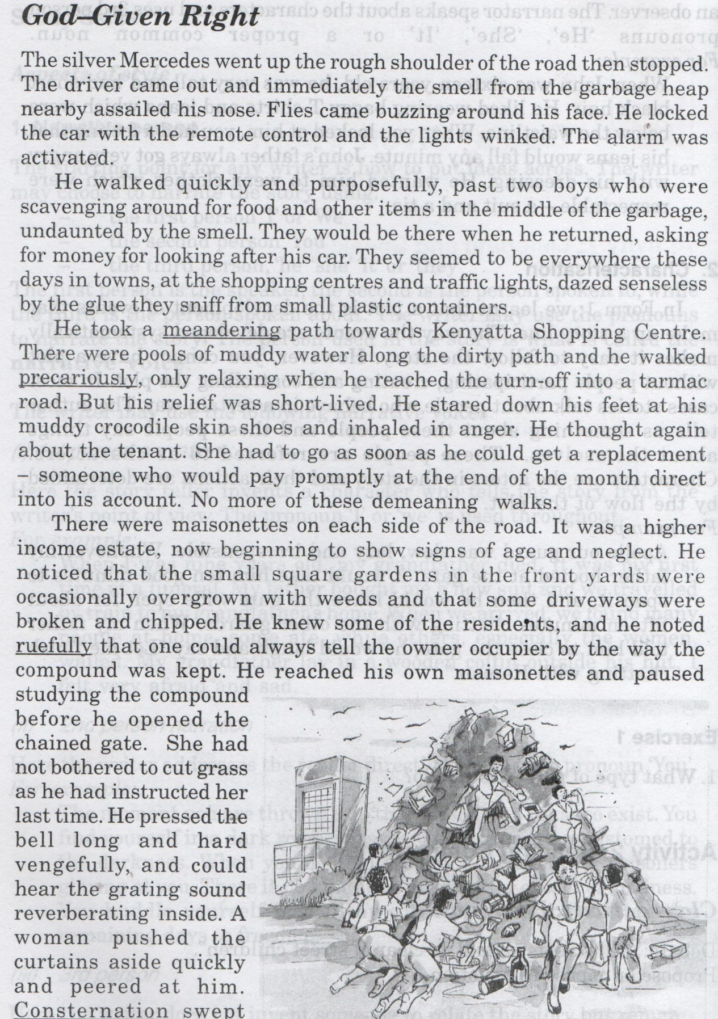

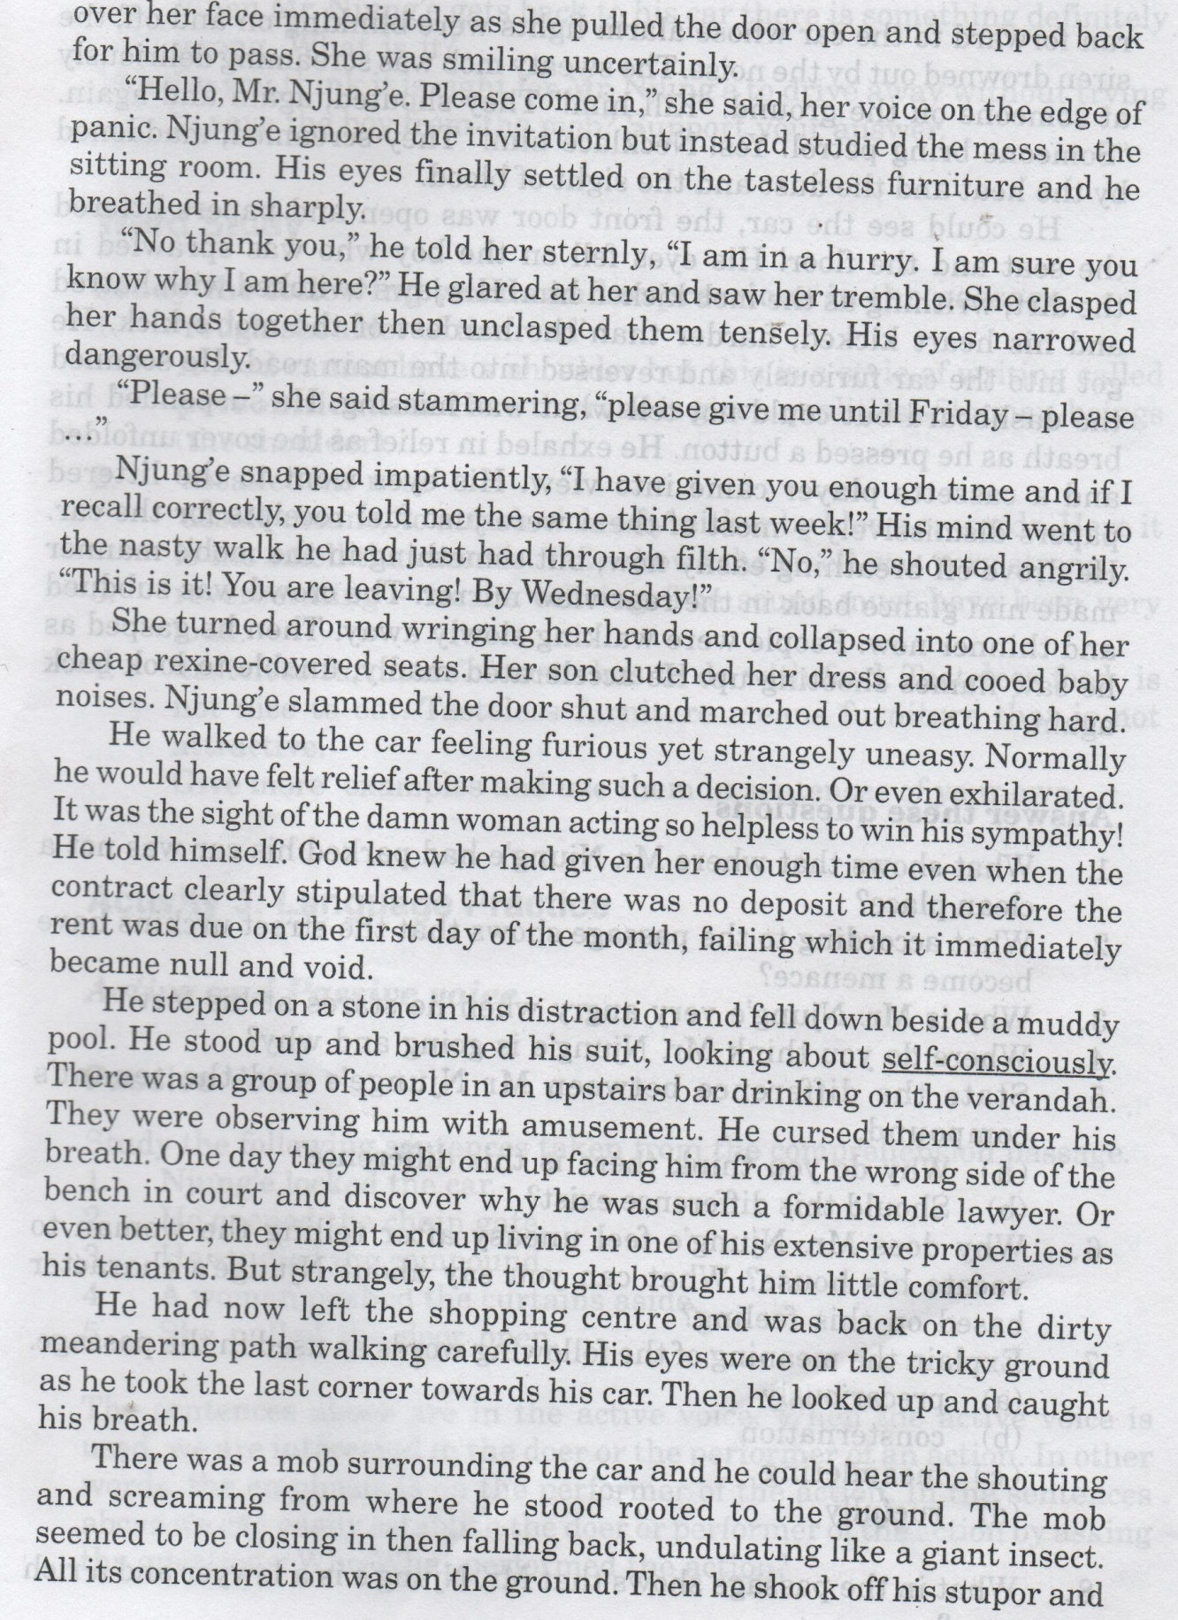

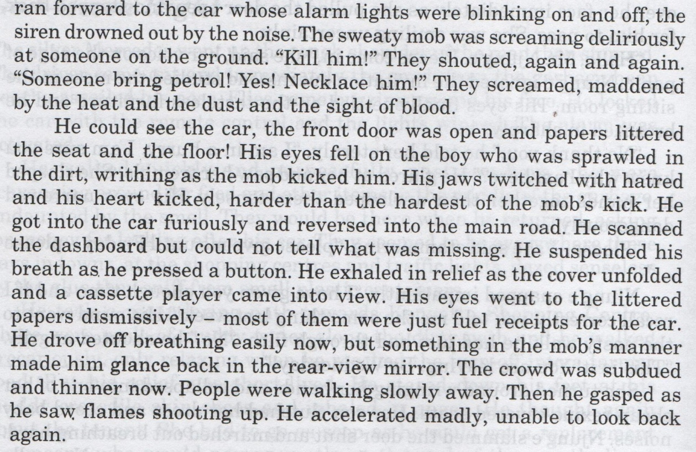

1. What shows that where Mr. Njung’e had parked his car was not a clean place? (2mks)
2. What according to the passage shows that the street urchins have become a menace? (2 mks)
3. Why is Mr. Njung’e very angry when he stares at his feet? (2 marks)
4. Where do you think Mr. Njung’e is going and why? (2marks)
5. State the difference between Mr. Njung’e’s and the tenant’s compound? (2marks)
6. Why does Mr. njung’e feel uneasy after telling the woman to vacate his house? (2 marks)
7. What can you say about Njung’e’s character? (2marks)
8. Explain the meaning of the following words as used in the passage. (4 mks)
9. Precariously-
10. Consternation-
11. Meandering-
12. Ruefully-

**GRAMMAR. (20 marks)**

**choose the correct alternative to complete each of these sentences. (4 marks)**

1. She is the ____________ (tallest, taller) of the twins.
2. You have to __________ (proof/prove) your answer is correct.
3. The bus _______________ (bust/ burst) into flames.
4. Joan and Peter _________(is/are) to blame for the mess in the classroom.

**Explain the two possible meanings of the following sentence.**

Mr. Kariuki gave the boy his coat. (2marks)

_________________________________________________________________________________________________________________________________________________________________________________________________________

**Arrange the adjectives in these sentences in their correct order. (4marks)**

1. He is _________________ _____________________ (old,intelligent,African) man.
2. Ours was a _________________________________ (round,new,leather) ball.
3. She bought ________________________________ ( oval,American,nice) car.
4. Obiri _________________________________ (Kenyan ,youthful, muscular)athlete.

**Rewrite the sentences below by changing the verb, into the aspect indicated in brackets. (4 marks)**

1. I will go to a university.(future perfect)
2. I ate all the food.(past perfect)
3. I saw a lot of money in the bag.(past perfect progressive)
4. The club collected a lot of cash during the fundraising. (present perfect)

**Use the correct form of the adjective in brackets to fill in the blank spaces. (4 marks)**

1. The field was too __________ to play in.(mud)
2. The problem now looks more __________________ than before.(manage)
3. Martin is a ______________ little bay.(mischief)
4. You should not eat _________________ fruits if you have ulcers.(acid)

**Choose the correct alternative from the brackets to complete the following sentences. (2 marks)**

1. These ____________ (chiefs, chiefs’, chief’s) children go to good schools.
2. That ________________ (companies, company’s, companies’) money is in good hands.

**ORAL LITERATURE. (10marks)**

**Read the following story and answer the questions that follow**

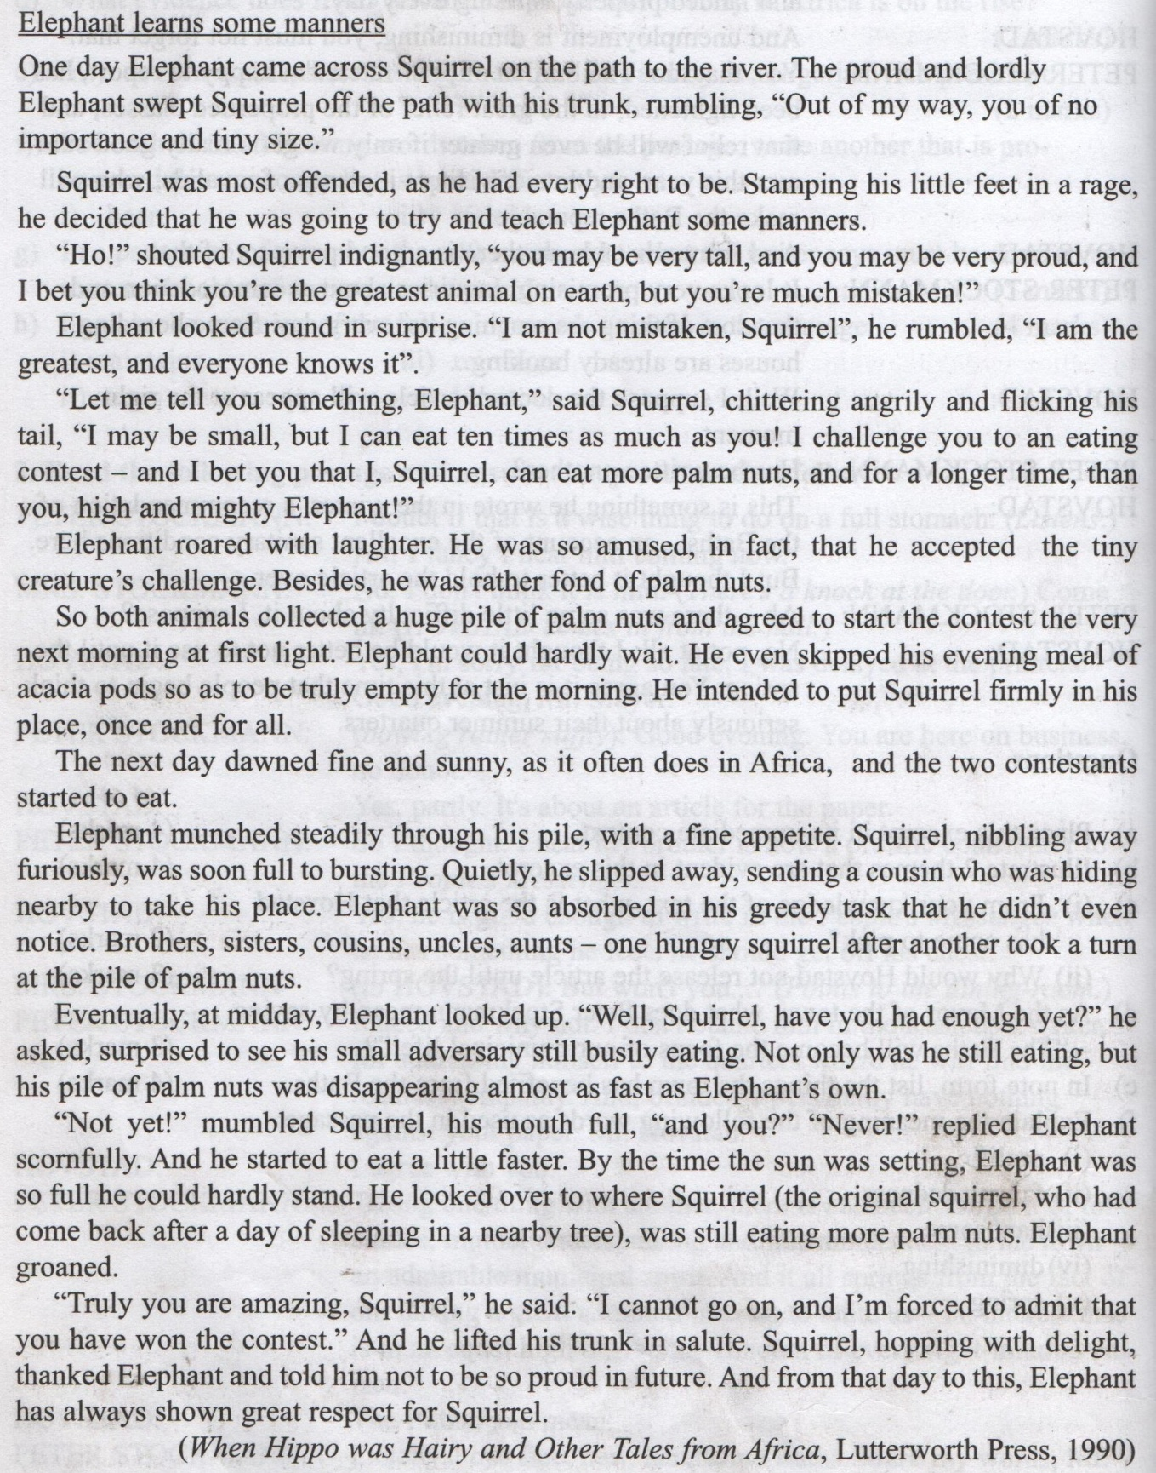

**Questions**

1. Classify the above genre. Give a reason for your answer. (2mks)

2. What features of oral narratives are evident in the above narrative? (3marks)

3. Identify and illustrate character traits of: (4 marks)

i) Elephant-

ii) squirrel-

4. Identify **two** moral lessons one can learn from this story (1marks)